Self-Service Design Patterns in Online Channels
Ramkumar Iyer, Cognizant Technology Solutions, Ramkumar.iyer@cognizant.com, Ramkumar.iyer@gmail.com

In this paper, we present patterns discovered during the architecture, design and operation of self service systems for one the world’s largest utility companies for both award winning business and customer facing web sites/portals and mobile applications. The company has around 3 million users with around 30000 transactions per hour. We classify the patterns based on, behavior, aids, customer, channel and relationship and provide a helpful map for architects and designers of such systems.
Categories and Subject Descriptors: E-commerce, Self Service, Utility, Banking, Digital, Online, e-Governance, Patterns
General Terms: Self Service
Additional Key Words and Phrases: Web site design, Channel design, Task Design, User Experience, Human Computer Interaction, Customer Relationship Management, Communication, Analytics
ACM Reference Format:
Ramkumar Iyer. 2013. Self Service Design Patterns in Digital Channels. GuruPLOP

INTRODUCTION
E-commerce patterns have been widely documented in the literature by IBM e-business patterns [2] as well as various design patterns for e-commerce websites [4,5]. These papers often talk about the conflicting objectives of customers and the commercial system: while the customer wants a quick and cheap deal, the commercial system wants to sell them more goods and services. However there exists a significant gap in the literature when these e-commerce systems are not designed for trade but for customer self service like banking, bill payment, after sales support or a ticketing website. These sites may be typically motivated to reduce the cost of the customer calling a non-online channel like a call center.

For example, in the utility company from which many examples for this paper are taken, the customers use the online channel (website) to do a large volume of self-service operations. The cost of serving this call in a dedicated call center is around 15$ per call compared to less than 1$ for the online channel. Online self service, if done right, can lead to huge cost benefits as well as revenue potential by being a brand differentiator. This can be opposed to say an e-commerce purchase web site where the major objective of customer is speed and seamless self service. The major objective of the self service provider over digital channels is cost reduction and relationship building.

Architects and designers at self service providers who want to provide self service in a cost effective fashion along with good user experience to their customers are the primary audience of these patterns.

Table 1 below illustrates the customer service, customer self service IT, customer information service IT Customer Relationship Management (CRM), and BPO (Business Process Outsourcing) expenditures across a wide variety of locations to illustrate those organizations that invest heavily in such systems. It should be noted that there is no profit figure because the measure of success is typically in form of customer satisfaction scores that are often integrated into the channel or extracted from analytics on the channel.

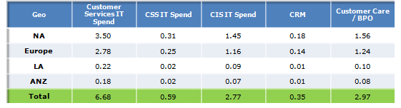

Table 1: Sample Customer Self Service (CSS), Customer Information System, Customer Relationship Management Spending for 2012. Source: Gartner. Figures in Billion USD

Table 2 depicts the parameters on which customer satisfaction is measured for a typical UK energy supplier. We can note that customer service, bill accuracy, energy friendliness and value for money from major integrated components for customer satisfaction.

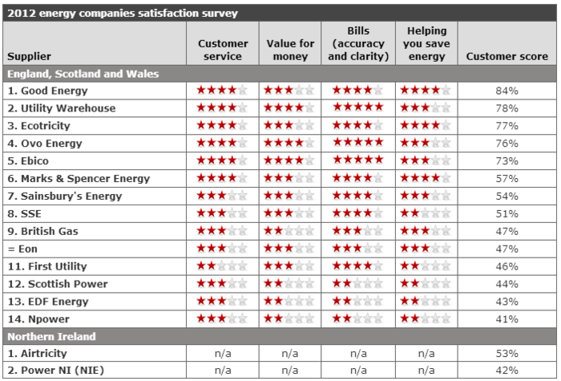
Table 1: 2012 customer satisfaction survey for Energy Suppliers

Definitions

Name | Definition | Also referred as
Customer Relationship Management | Customer relationship management (CRM) is a model for managing a company’s interactions with current and future customers, using technology to organize, automate, and synchronize sales, marketing, customer service, and technical support. | Relationship
Self Service | Methods and processes a business uses to allow its customers to complete most steps in purchasing products or services on their own -- such as shopping in a retail store or making a call to arrange a service. Self-service also extends to Web-based transactions and CRM whereby customers manage account information primarily on their own. Typically self service does not involve another human being [6] | Self Service System
Self Serve | The act of self service is often referred as self serve | Self Service Task
Online Channel | An online channel is connected to the customer via a digital network allowing for two way transfer of content. | Digital Channel, Website, Site

Figure 1: Sample Diagram of the self service problem space (the hardware is indicative)

Figure 1 above depicts the self service happening between the customer and self service provider over an online channel with some key concerns of the participants in the exchange which will be elaborated in the next section.

Modeling the Patterns

We define the self service using a simple linguistic statement:

Customers engage in Behaviors to satisfy Objectives with Aids on the Channel to build Relationship (CBOACR)

We wish to highlight the use of the word “Aid” as opposed to say Incentive, as we feel self service should be suggested via aids to the customer, and not just sold to customers as offers and deals. We also see that the end point of a good self service interaction is a good long term relationship with the brand. For example a practical example for that the statement is “Joe submits a meter read with a meter read widget so that his bill is accurate using a wizard in the online channel to build a relationship with the brand”. Or “Jill sets up a direct debit with a cost estimation tool to build a trusted relationship with the brand”. While describing these patterns, care has been taken to make them technology agnostic and combinable.

FORCES IN SELF SERVICE
Force | Description | Example | Abbreviation
Lack of Time | Customers often lack time to fill in the data for a complex task | Customers may want to purchase a ticket involving multiple stops, multiple inter-related tasks like booking hotels but may have very limited time | TIME
Lack of Knowledge | Customer may lack knowledge to complete the self service task effectively | Customers may want to pay a bill but may not know if direct debit is better or whether paying by credit card is better. | KNOW
Computing Constraints | Customers often have non standard equipment | Customers may have only a low speed connection or a mobile handset through which they may want to execute a complex task | COMP
Complexity of Steps or Interactions | Often multiple interrelated steps needs to be executed | Customers may have to move premises for the gas or electricity connection which may involve self service tasks that span multiple forms (new address. old address, supply meter data etc) and multiple providers. | CPLX
Cognitive Constraints | Customer may have to remember multiple things | Credit card numbers, pin codes, social security numbers need to remembered | COGN
Complexity of Self Service Objectives | Customer may have to keep track of a self service task | For authentication, customers have to keep track of the task across email and mobile | OBJ
Timing of Self Service Objectives | The self service task executed may not be done immediately | When moving a premise address for a connection if may take 3-4 days for each of the intermediate step like verification, credit vetting etc | ASYNC
Cognition, Perception and Deciphering of Aids | Customer aids must first be perceived, thought about and then deciphered | A graph may be displayed to compare outcomes of different ways of booking a ticket or different ways of completing a journey. This needs to be correctly deciphered by customers. | AIDS
Learning Effects | Customers learn the self service interface quickly | A customer who is submitting meter reads for the 10th time will certainly be faster provided the self service interface is same | LEARN
Channel Capacity | The website may have low bandwidth for customers to be effective. | Customers may connect across low bandwidth mechanisms like GPRS or high bandwidth mechanisms like fiber optics | CAP
Channel Heterogeneity | Customers have to interact with multiple types of channels | Customers may have to interact across multiple channels like website, email, SMS thus making it difficult for them. | HETER
Service Cost | The service cost for online channels are an order of magnitude less than a channel involving real human interaction and real dedicated resources. | Cost of a call center call maybe up to 15 times higher than a online transaction to download or view a bill as per our experience | COST
Short Term versus Long Term | The channel providing organization may want to bring about a long term relationship with the customer but the customer is only on website for a short term to complete their task. | A ticket booking website may want people to choose the website over others for repeated tasks over a period of time rather than in an use and throw manner. | TERM
Offline attitude versus online experience | Customers may form perceptions of the brand offline based on their online experience on the self service website. | If self service experience is poor, customers may form poor opinions of overall customer service provided by the service provider. | ONLN
Trust | Customers may not trust their service providers | Customers are generally wary of service providers offering them below par service, leaking their privacy, indulging in surveillance and generally not safeguarding their data | TRUST

PATTERN TEMPLATE

Context Specific name
Specific context | In what environment(s) do we see this problem?
Problem | What is the problem we are trying to solve?
Example | An example of the problem.
Forces | What makes this problem hard to solve? What are the benefits and liabilities of the potential solutions?
Solution | How we solve the problem.
Solution example | An example of the solution based on the problem example
Resulting Context | What is the environment created by application of the solution?
Related Patterns | Other patterns in the language related to this one.
Known Uses | Examples of patterns found in real systems
Negative Consequences | Does this pattern have negative consequences? If so what is the mitigation?
Confidence Level | - “No asterisk means that we are not very sure about the patterns content.  - One asterisk means that we think the patterns are valid, but we are not sure about details, formulations or all the forces.  - Two asterisks mean that the pattern is a fact.”  From [9]
Technology Applications | Practical technologies, standards, open source libraries used to implement these patterns. References are not provided but readers are encouraged to a web search engine to discover further on the same. These are available at  [10]. The technology applications will be under rapid change.
Illustration | A generic free to use image search based illustration of the concept

PATTERN DIAGRAM
The below diagram illustrates the patterns that are discussed, relationships among them and forces each of them resolves.

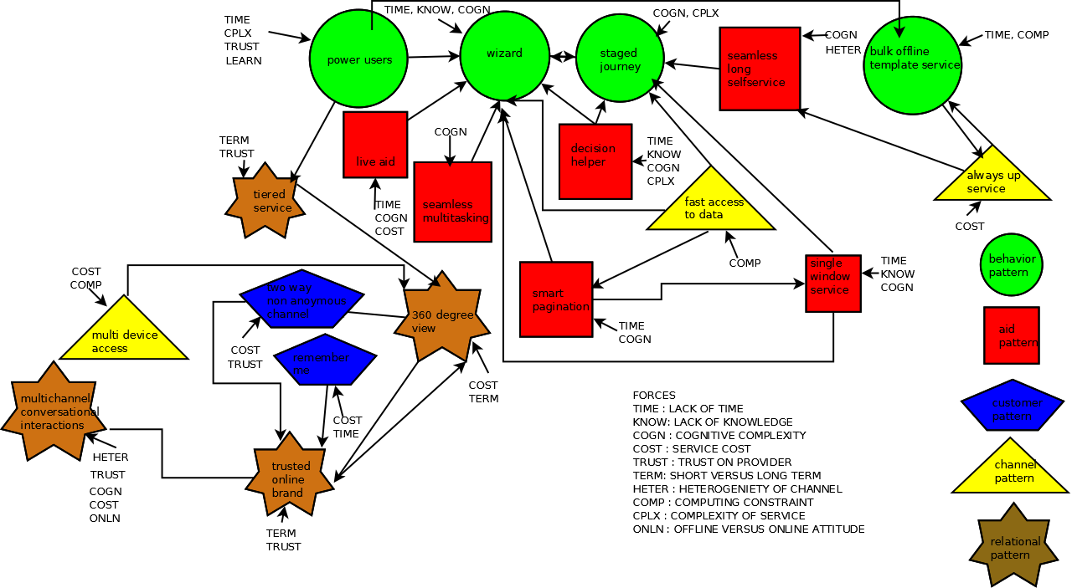

Figure 2: Interlinked self service patterns to evolve into a pattern language along with their classification and forces

A brief description of the classification follows

- Behavior Patterns: These patterns directly relate to the behavior of the customer who self serves in the self service system and common solutions to getting the needed behavior. These patterns are important because they directly focus on the behavior that customer undertakes when doing self service tasks. Typically, by guiding a customer into a patterned behavior it makes it easy to build interfaces that can scale for the same service provider in terms of usability and quick learning. The reader should look at this group of patterns as guidelines along which customer behavior can be shaped. These are patterns that are the closest to Human Computer Interaction discipline.
- Aid Patterns: These patterns relate to the aids provided in the self service system to provide the needed solutions to the self service task. The patterns are important because they directly provide assistance to the customer who is executing the self service task. The patterns typically provide analytical information which is personalized, or provide interventions when necessary, or provide cognitive aids which help further the behavioral objectives. The reader should look at these patterns in terms of contextual clues which aid behavior. These patterns are closest to the analytical discipline.
- Customer Patterns: These patterns directly relate to the customer who is undergoing the self serve and various solutions the problems. These patterns are the second most important because they relate to the core user who is executing the self service task. By appropriately personalizing and creating a two way conversation the customer can experience a feeling of being known by an intelligent system. The reader should look at these patterns mainly for getting a core understanding of the most important participant in the self serve. These patterns are closest to sciences of psychology, sociology and cognitive science.
- Channel Patterns: These patterns relate to the problems that occur due to the online nature of the self service channel and the various solutions. These patterns are important because the channels to some extent determine what can and cannot be technologically achieved within the scope of the self service task. “The medium is the message” is an oft quoted statement and to a large extent the medium does shape the message. The reader should look into these patterns to understand the capabilities of the channel that is used for self serve and which can also distort or enhance the customer experience. These patterns are closest to the information and communication disciplines.
- Relationship Patterns: These patterns relate to the overall relationship that the self service provider seeks with the customer and the solutions found to the various problems. These patterns are the most important because the self service provider wants to generally grow the relationship with the customer from just being a provider of automation for some of their self service tasks to someone the customer can recognize as a trusted brand and choose preferentially over others. The reader should look into the patterns as the sort of overall long term strategy. The service provider should pursue these patterns to enable a long lasting relationship with the customer. These patterns are closest to the business disciplines of marketing.

Behavior Patterns

BULK OFFLINE TEMPLATE SERVICE
Specific context | Environments where multiple repetitive self serve tasks ranging beyond 5-10 tasks
Problem | The customer has to complete lot of self serve tasks but the number of tasks is too high
Example | A user may need to submit a 100 meter reads to an energy utility for all the businesses he or she owns.
Forces | Lack of Time, Computing Constraints
Solution | Create a template for multiple self serve tasks and allow the template to be filled in offline and submit at a single shot
Solution example | A template is provided to the user with header. This template can be a comma separated value file. The comma separated value file can be uploaded with the meter reads and meter identification numbers is submitted.
Resulting Context | User is able to automate multiple self serve tasks using provided templates.
Related Patterns | Power User : as power users typically want to do multiple things at once  Always up service : as users want to work in an always online mode even if offline
Known Uses | Money management software has power users who can upload their bills. Social management software also allows import and export of contacts.
Negative Consequences | This introduces a complexity with respect to maintaining compatible file interchange formats. The template that users fill in with data need to validated. As mitigation we can consider simple interchange formats.
Confidence Level | **
Illustration | 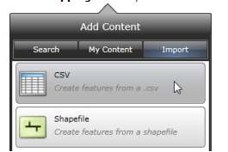

STAGED JOURNEY

Specific context | Multi-step complex memory based behavior needed to satisfy objectives. Customer has to complete lots of tasks in a sequential order. He or she may be interrupted and may need to resume at a certain place
Problem | How to ensure such a complex multiple steps self serve task can be executed?
Example | When we need to register a user a multitude of information may be asked in self serve. Customer may not have some information handy and there will be considerable think times. It is easy to lead them through a patterned journey of multiple steps
Forces | Customers may often lose track of where they are in a long process involving multiple steps. The two forces are cognitive constraints and complexity of steps.
Solution | The solution consists of multiple sub solutions. Model the problem as a journey with stops in between. Provide intermediate feedback. Store the state at every stop. Allow interrupted journeys to resume. Aids in the form of journey like imagery are extremely useful.
Solution example | A stage wise journey form with collapsible sections on multiple pages.
Resulting Context | A progressive solution to the self serve problem
Related Patterns | Wizard : As it can reduce think time in the user journey from point A to B
Known uses | Many ATM machines use a journey pattern
Negative Consequences | If a journey pattern is used, journeys tend to get longer for complex problems and the user may feel frustration. This can be mitigated by keep journeys small and chaining them.
Confidence Level | *
Illustration | 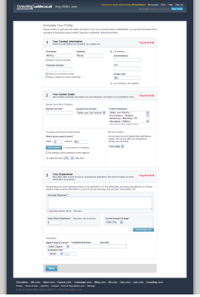

WIZARD
Specific context | Multi-step complex memory based and domain aware behavior needed to satisfy objectives. User has to make informed decisions on a variety of self serve tasks
Problem | How to ensure the adequate information is provided the user to make the correct decisions on a variety of self serve tasks?
Example | User needs to select a specific energy plan (including green energy, his or her insulation needs) on an energy website.
Forces | Lack of Time, Lack of Knowledge, Cognitive Complexity
Solution | Create an intelligent wizard that embodies different decision models and guides the users.
Solution example | User has a energy plan wizard which guides them through an optimal path for selecting their energy plan based on cost, their environment and past energy bills
Resulting Context | Fast selection among complex decision options.
Related Patterns | Staged journey : Most wizards are modeled as journeys that can take multiple paths based on user choices
Known uses | Configuring cloud instances on Amazon cloud servers often provides wizards. Some sales tools that generate customer proposals like Bigmachines will automatically detect sales of conflicting hardware and software.
Negative Consequence | It is often possible that the users click rapidly through all the elements of a wizard like interface unaware of changes that occur. For example, they could select a software configuration which is ill suited for them. To mitigate the same Wizards should include warnings and provide auto-detection functionality. They should also provided standard automated solutions for normal users.
Confidence Level | **
Illutsration | 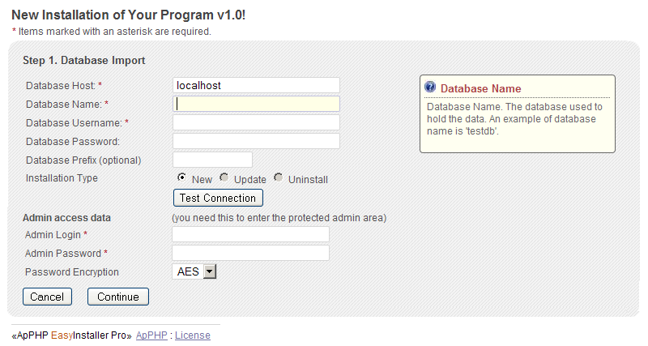

POWER USERS

Specific context | Users want better self service as they grow used to the channel and existing self service interfaces
Problem | How to enable customers to chose better methods of self service given the same set of service options meeting the customer objectives?
Example | For example users may want to pay their bills with one click
Forces | Lack of Time, Complexity, Learning effects, Trust
Solution | Create an interface option that allows bypassing some self serve choices.
Solution example | A checkbox for power users that allows bypassing repetitive self serve.
Resulting Context | A faster self service experience for experience users.
Related Patterns | Wizard : For faster decision making  Tiered Service : For faster access to shared assets
Known uses | GoDaddy providing hosting often stores credit card information for reuse.
Negative Consequences | The pattern may increase the mistakes that can be made by the unaware, so some caution must be applied for self service tasks that cannot be reverted. For example they may auto-renew services they no longer need or even these journeys may not be childproof.
Confidence Level | *
Illustration | 

AID PATTERNS

DECISION HELPER

Specific context | Choice among competing options with weights attached to each attribute of the option.
Problem | Customer has to make choices between various self service options.
Example | Customer has to choose between different payments plans like monthly, yearly. Choose insurance policies. Choose types of train tickets at a railroad.
Forces | Lack of time, Lack of Knowledge  Complexity of steps, Cognitive constraints for Behavior
Solution | Create tabular comparison sheets with the overall cost highlighted
Solution example | A table displaying various payment plans. A graph comparing various options
Resulting Context | Reduction in time to make decision. More optimal decisions
Related Patterns | Staged journey: Typically used in Journeys to guide the user.  Maybe integrated in the Wizard
Known uses | Tables, Graphs, Charts are used in Intuit Money Manager to show split among multiple items
Negative Consequences | The decision aids provided to the user should be easily decipherable across various cultural barrier. It is rare for one decision aid to actually help the user so multiple decision aids should be provided.
Confidence Level | **
Illustration | 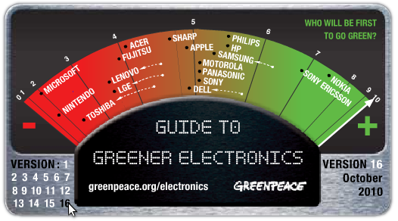

SINGLE WINDOW SERVICE
Specific context | Display multiple self serve options to the customer
Problem | How can multiple self serve options displayed to a customer efficiently?
Example | Customer has a 100 self serve options like pay bill, view energy consumption, move premises etc. How to display them efficiently?
Forces | Lack of time, Lack of knowledge, Cognitive Constraints
Solution | Create a navigational system that helps the user to navigate between all the self serve options without losing the context and having to load multiple pages
Solution example | Create a compact/condensed single page or faceted navigation system. This must go hand in hand with selecting the appropriate layouts which will be in line with the displays the customer may use to access the self serve system.
Resulting Context | One stop self serve place which is easily book-markable.
Related Patterns | Wizard : To generate the self serve page effectively  Staged journey : To navigate the self serve page effectively
Known uses | MegaMenu, Springboard, Faceted Navigation all given in [7]
Negative Consequences | In some cases it is difficult to show all the decision options in a single page so techniques like infinite scrolling and swipe based navigation are used to give feeling that all options are on the same page. However, in such cases the discovery of self service options will take time as the user manually has to navigate to each and every option. In some cases even the options are dynamic. For example, some operating systems mix the cloud applications along with local applications to provide a single seamless view although that will only work if the user is online. There are techniques like speech recognition which can take the user to the right location with speech alone. However this may hamper discovery of the options. Thus this remains a complicated problem to solve.
Confidence Level
Illustration | 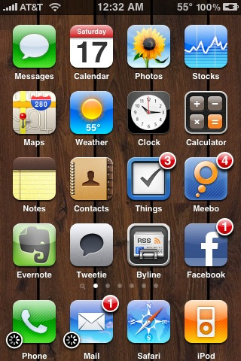

SMART PAGINATION

Specific context | When customer has to view large volumes of data in multiple renderings
Problem | There is a lot of self service data for the customer. How to display it for good comprehension?
Example | Customer wants to see top ten bills. Sometimes they want to see all their bills. Sometimes they want to see bills that they have paid.
Forces | Time Complexity, Cognitive Constraints
Solution | Create multiple pagination options or views. Allow the user to switch between these views. Make the most used view as the default view. If the customer makes persistent use of one of the views make that the default view.
Solution example | Pagination by top ten bills, pagination by last 3 months, and pagination by payment status could be provided and it would also allow for sorting.
Resulting Context | Multiple views of large volumes of data allowing for efficient selection.
Related Patterns | Wizard : To create smart pages from data  Single Window Service: To keep all the smart pages in single location  Decision Helper : To aid choices
Known uses | HDFC bank allows quick account summary and account summary by period
Negative Consequences | If there are too many pagination options, user confusion may increase, seeing variety of ways they can see the data when they are interested in a few data. A decision aid is the mitigation for such a case.
Confidence Level | **
Ilustration | 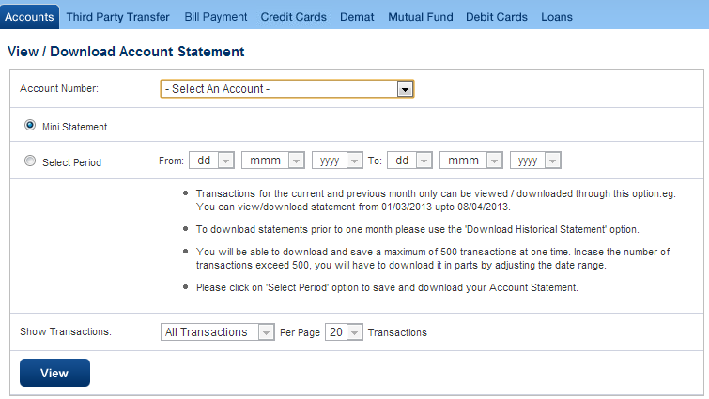

LIVE AID

Specific context | Current technologies cannot support immediate customer needs or the web channel is not optimized to provide the support the customer needs.
Problem | Customer may need immediate help while doing self serve. How can you avoid a costly switch to other channels and complete abandonment of the online channel?
Example | Customer has a complex question when accessing a self serve task. Maybe they dont understand the language or they are stuck
Forces | Time, Cognitive, Service Cost
Solution | Introduce human digital assistance
Solution example | Customer and Smart context based digital chats
Resulting Context | Human assistance when really needed
Related Patterns | Wizard : A human closely resembles a wizard who is experienced at the task on hand
Known uses | Websites like Samsung have chat line for their customer service
Negative Consequences | If such functionality exists, users may start using this any time and all the time thereby skipping the online self serve. The mitigation is to only provide the chat window to appear at appropriate complex positions in the online work flow, which is complex. The other negative consequence is that the chat window agent may have no idea of what the user is facing online. Some kind of mirror window could be opened to troubleshoot the customer problems. The third negative consequence is that there will be wait time required to provide the live aid. This can be mitigated by showing to customer how much time he/she has left to get live aid and also allow mechanism for the live aid to activate the channel to customer when customer is free.
Confidence Level | *
Ilustration | 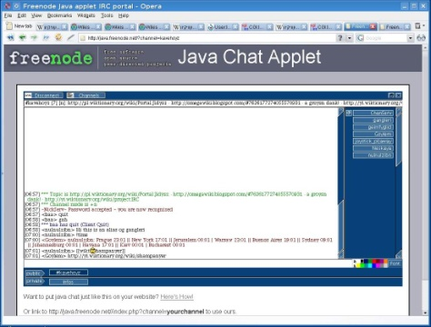

SEAMLESS LONG SELFSERVICE
Specific context | Customers want to do long running transactions over periods of days
Problem | Customer may need storage of intermediate steps or final steps of their transactions
Example | Customer wants to complete a moving premises task for a gas connection that takes a week. Customer wants to submit an appraisal form over a month.
Forces | Cognitive Constraints, Heterogeneity of channels
Solution | After customer completes part of a long running self serve task, send a message with a link to continue over other channels
Solution example | For example, customer can be sent an email after 15 minutes for a task of 1 hour with an intermediate state to continue later
Resulting Context | Seamless, long running. self serve access
Related Patterns | Staged journey : Journeys can have long service times.
Known uses | Customer sells shares online and receives messages on SMS after one week that shares are sold.
Negative Consequences | The customer may have changed his or her mind or requirement in the midst of long running self serve tasks. The mitigation is to provide a cancellation mechanism. The customer might have forgotten about the long running self serve task. The mitigation is to provide enough context for him or her on the task status to proceed further.
Confidence Level | **
Illustration | 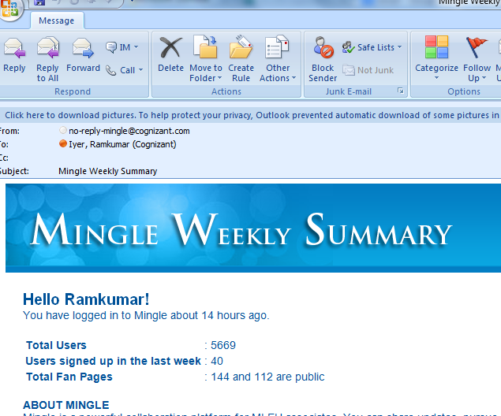

SEAMLESS MULTITASKING
Specific context | Customers are executing self serve tasks in parallel.
Problem | Customer may have performed or may need to perform many self serve tasks. How to keep the customers informed?
Example | Customer does a payment which will take 15 minutes to be acknowledged. He also does a change of his password
Forces | Cognitive Complexity
Solution | Message Center or Notification Center with task outputs.
Solution example | Design a notification queue or message center that allows customer to received delayed feedback on self serve tasks.
Resulting Context | Seamless multi task execution
Related Patterns | Live Aid : So messages could be chat based and require assistance  Wizard : Some messages can be processed via a wizard
Known Uses | Facebook application on mobile has icons with cues of pending messages
Negative Consequences | The notification queue or message center or any other solution to the multitasking problem can be overloaded with too many messages/reminders/alerts some of which require urgent attention and some may do with lesser attention. Thus designers must take care to segregate these types of messages and also provide a solution to the user in order to delete unwanted notifications.
Confidence Level | **
Illutsration | 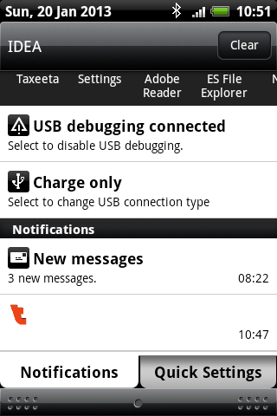

CUSToMER PATTERNS

2 WAY NON-ANONYMOUS CHANNEL
Specific context | When the service provider needs two way communication but customer is anonymous
Problem | Anonymous customers cannot be provided optimized self service. How to ensure that end customers are not an anonymous entity in the online channel?
Example | Site wants to send a feedback on a self serve task but customer is anonymous
Forces | Service Cost, Trust
Solution | Create account management functionality which allows users to provide contact information as well as allows them to be. Thus the users are no longer anonymous.
Solution example | Login functionality capturing email and phone number
Resulting Context | 2 way non anonymous channel
Related Patterns | 360 degree view : To store and track this customer data  Trusted online brand : To assure the user that his data is not abused
Known uses | Tata photon website allows anonymous bill pay as well as logged in bill pay. While logged in, users are shown additional usages and other efficient plans.
Negative Consequence | Once customer account management feature resulting in two way non-anonymous channel, the safety and security infrastructure needed at the backend also increases tremendously. To mitigate this strong security measures need to be put in backend including things like automatically changing passwords, CAPTCHAs and creating password reset infrastructure. Further customers start demanding increased service due to non anonymity which can be remedied by providing them with specialized items like coupons or lower bills. Some customers who prefer to be anonymous may need to be served so all critical self serve activities should have an anonymous mode.
Confidence Level | **
Illustration | 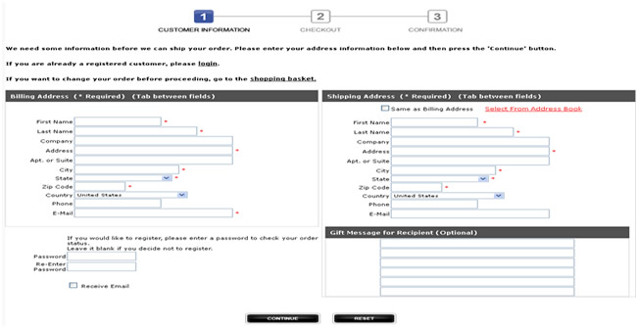

REMEMEBER ME

Specific context | Customer preferences are lost when executing repetitive self serve tasks
Problem | If the customer is always treated as new customer then we lose valuable information about their preference like their cognitive style or decision preferences. How to ensure that the self service customer provides an interface that can learn over time?
Example | Customer wants to pay bill always with their same credit card.
Forces | Service Cost, Lack of Time.
Solution | Stores the likes, dislikes and the customer data and keep it updated. This can be leveraged when the customer executes the self service task repeatedlyhey execute new self serve tasks.
Solution example | Store customers old credit card information securely and allow to use the same
Resulting Context | Customer feels like a known entity. Personalization occurs.
Related Patterns | 2 way non anonymous channel: As this is the area from which the information about preferences may be captured.
Known uses | GoDaddy stores credit card information for reuse
Negative Consequence | The stored data of the customer must be constantly updated. He could have changed his credit card, moved premises, started to have different culinary taste between the time he expressed his preferences in the site and the time he accesses the site. To mitigate the preferences must allow for change from existing preferences.
Confidence Level | **
Illustration | 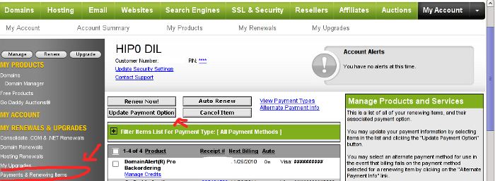

CHANNEL PATTERNS

FAST ACCESS TO DATA

Specific context | Customer does repetitive self serve tasks on huge volumes of backend data
Problem | The customer may do multiple self serve actions. This results in costly backend calls to the system in terms of time and bandwidth. How do you enable customers to do repetitive self service tasks efficiently when large volumes of data are transferred over the online channel?
Example | Customer may want to view 100s of his bills, then go and buy a plan and view the bills again
Forces | Computing Constraints
Solution | Create a backend cache to store all the frequently used data for the customer right in the frontend making backend calls un-necessary and respond faster.
Solution example | Store data in the browser for his bills till he comes back.
Resulting Context | Faster access to data
Related Patterns | Wizard : Which allows decisions which utilizes local data  Staged journey : Which allows a step by step procedure  Smart Pagination : Which allows snapshots of data rather than all the data
Known uses | Google docs caches customer data even if offline
Negative Consequences | Caches may quickly increase in size and may need to deleted for other programs to run smoothly especially in resource starved environments. Hence caching strategy should heavily depend on the nature of end device the customer is using and should be optimized. Caches also have to be secure.
Confidence Level | *
Illustration | 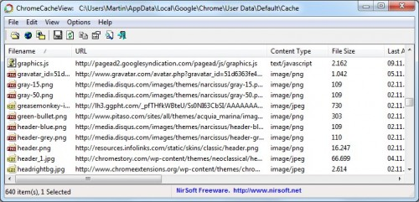

MULTIDEVICE ACCESS

Specific context | Customer has multiple devices or multiple access channels
Problem | The customer may do multiple self serve access like devices on same channel: mobile, tablet, a browser. How to create a unique self serve across multiple customer devices?
Example | Customer has a tablet, a smart phone and a PC and wants to use same self serve application.
Forces | Computing constraints, Service Cost
Solution | A hybrid application supporting multiple devices is one which offers a customized online channel experience for various devices.
Solution example | An application store where customer can download a shrink wrapped hybrid app for their device for his specific device. The hybrid app mixes both the best features of a pure online access as well as allows for native feature access.
Resulting Context | Multi device access
Related Patterns | 360 degree view: By having same app across multiple devices it is easier to integrate and build 360 degree view.
Known uses | HDFC bank has a mobile app for payment. Paytm is a new service launched focused only on utility payments
Negative Consequences | Hybrid applications are not as fast and don’t have same look and feel as the native applications which may lead to a bad user experience. Hence look and feel and speed needs to be critically monitored for hybrid apps.
Confidence Level | *
Illustration | 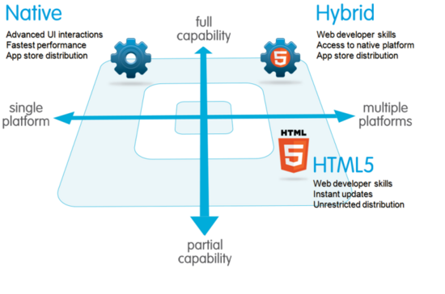

ALWAYS UP SERVICE

Specific context | Digital channels are not always available.99.9% is common.
Problem | Some customer self service operations may be down. How to ensure the completion of self service even when backend systems could be down?
Example | Some services like payments are down. How to still allow them?
Forces | Service Cost
Solution | Disconnected operation where self service task is queued till operations resume.
Solution example | Allow self service but commit the payment only when services are up. Customer sees no difference
Resulting Context | Simulation of always up.
Related Patterns | Seamless Long Self-Service: This can send small messages on flaky connections of the system state.  Bulk Offline Template Service : This can be used to work offline
Negative Consequence | When multiple customers access the same data and are offline they may make mutually incompatible changes. To mitigate these factors synchronization software needs to be written.
Known uses | Some mail clients will put mail in outbox and send when connection is available demonstrated in illustration below
Confidence Level | *
Illustration | 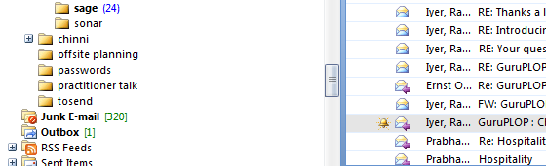

RELATIONAL PATTERNS

MULTICHANNEL CONVERSATIONAL INTERACTIONS
Specific context | Customer does self serve and forgets the provider
Problem | Once the customer moves away from self serve, the self serve organization desires to build trust and relations. How to ensure that the self service provider is in the mind of the customer even after customer has finished the self serve task?
Example | Customer is not able to build long term relationship with self serve
Forces | Cognitive Complexity, Trust, Service Cost, Offline versus Online, Heterogeneity
Solution | Create a multichannel feedback allowing for relationships.
Solution example | Email/SMS/Survey/Social/Ratings can be provided
Resulting Context | Customer feels part of 2 way conversation if the communication is personalized, individualized and dialogic
Related Patterns | 360 Degree View : A 360 degree view allows multichannel feedback as it contains all the data of customer which can be used to channelize information and build relationships
Negative Consequences | Customer may start treating the communication as spam or may not wish to be disturbed on other channels. The mitigation is to make it opt-in type of access or provide questionnaire as to their area of interest and channel of preference. An opt-out should be provided in every communication a link to opt-out.
Known Uses | IRCTC communicates customized rail packages to its known customers
Confidence Level | **
Illutsrtation | 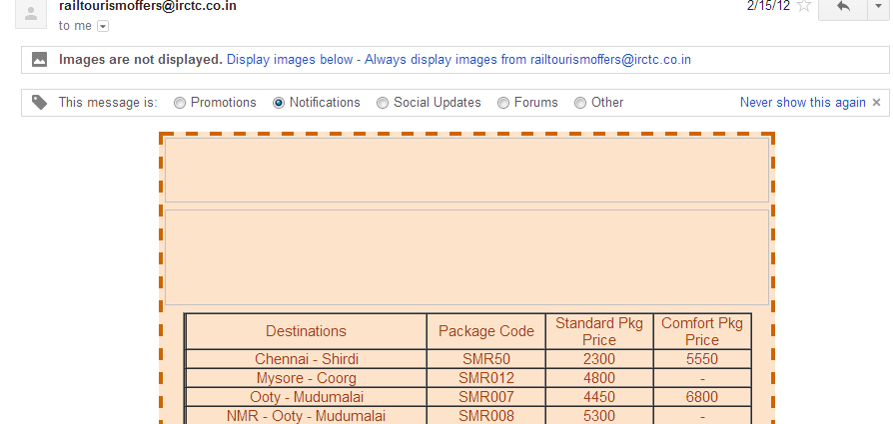

360 DEGREE VIEW

Specific context | Some customers may use multiple channels to interact. How to build a relationship?
Problem | Customers interact with self service providers through various channels that may be transactional, relationship-based or social. Typically data regarding these interactions are in separate silos, thus the company cannot have an integrated view of the customer. We call such an integrated view, a 360 degree view of the customer.  How does a system create 360 degree view of customer self serve to serve better?
Example | Some customers may call and pose a problem. Then they may go to a website and try to self serve and solve the problem. Then call back. They may post something about the self service task to a user forum. How to provide a unified view to service provider?
Forces | Service Cost, Short Term versus Long Term
Solution | Create a backend system with a multi channel 360 degree view.
Solution example | A backend integrated CRM system
Resulting Context | Seamless access. Full information
Related Patterns | Trusted online brand : For 360 degree view to work customer must feel data is private
Negative Consequences | Building a 360 degree view is challenging and may raise privacy concerns. Further customer data from things like social networks is rich and unstructured and cannot be quantitatively measured. Also significant infrastructure is needed to host a 360 degree view. The mitigation is to gradually build the view from incoming data on cloud based services.
Known uses | HDFC sends an SMS alert once you shop with debit/credit card, an alert when your salary is deposited and a end of month alert with bank-balances and an alert for third party transactions. They also allow to pay bills through the bank,
Confidence Level | *
Illustration | 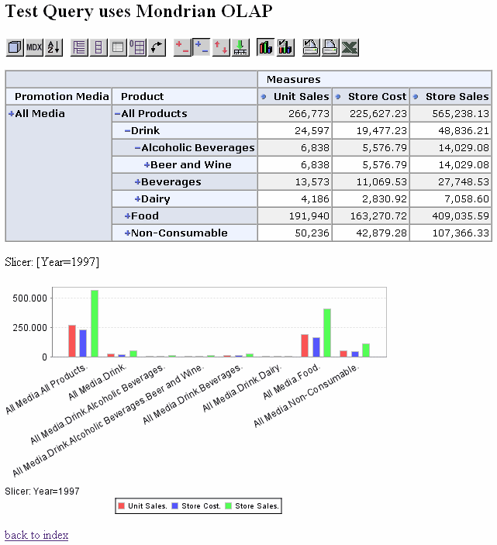

TRUSTED ONLINE BRAND
Specific context | Customer trust is low in online channels
Problem | Customers feel revealing information to self serve websites may compromise their privacy. How to assure customers that their privacy won’t be compromised?
Example | Customer does not trust a website with credit card information, personal details in fear they will be targeted or discriminated or robbed.
Forces | Short Term versus Long Term, Trust
Solution | Create a well defined working privacy policy
Solution example | A cookie tracking policy
Resulting Context | More trust and cooperation will result if the company crafts a well defined policy and adheres to the same.
Related Patterns | 360 Degree View : If you have more trust, then more customers will provide data for 360 Degree View
Negative Consequences | Having no working privacy policy, means you can monetize the clicks the user makes on the site as well as build referral networks at cost of customer privacy. This could be suitable in rare cases. However having a working privacy policy entails you to not sell customer data to third party, not to track the customer unless it is with their explicit permission, which is better in long run.
Known uses | All websites have well defined privacy policies in their footer
Confidence Level | *
Illustration | 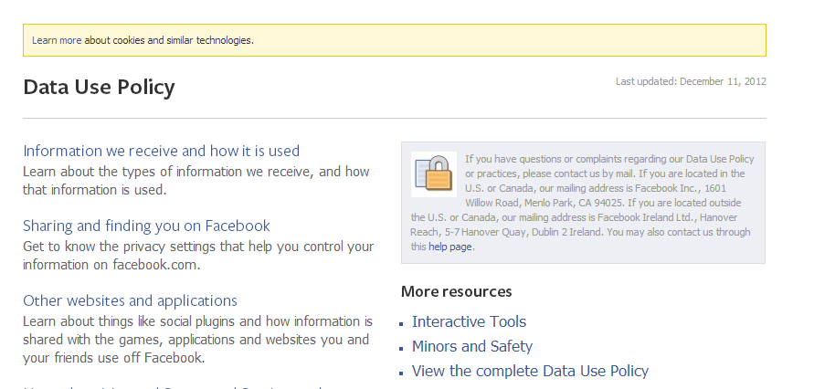

TIERED SERVICE
Specific context | There are multiple classes of segment-able users for the self service with different demands and differing capacities to pay for services. The resource on service provider side is limited.
Problem | How does the system serve some users at a different service level than others?
Example | Some customers are high paying or need a different class of self service and some are low paying for a file download website. How to differentiate?
Forces | Service Cost, Long term versus short term
Solution | Provide various classes of self service differentiated in terms of time, quality or cost. Segment the users and assign each segment to a given class.
Solution example | For example introduce a time delay for low paying customers who can afford to wait. We can also give discounts to customers who have used the online channel considerably more in the past as compared to other customers.
Resulting Context | People are served based on relationship value
Related Patterns | Trusted online brand : To ensure users don’t feel that some discrimination is happening
Negative Consequence | The drawback of this pattern is customers may not like being segmented to lower classes of service and migrate to other providers and the service provider must ensure that appropriate mechanisms to control for such backlash.
Known uses | Some internet download providers like deposit files add a slight delay to free download customers.
Confidence Level | *
Illustration | 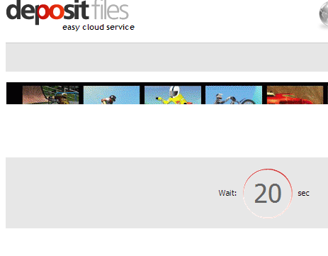

Summary

We have described patterns observed in customer self service over digital channels which can be used by practitioners like architects to design a world class self service system at a low cost and maximum customer satisfaction. The architect or designer can use these self serve patterns as map of the self serve territory. We have described the negative consequences of all the patterns and provided mitigation plan. We found documenting these patterns and communicating them across our enterprise provoked a lot of discussion which refined some our prototypes.

In India, as of 2013, companies like Paytm (https://www.paytm.com/), Redbus (http://www.redbus.in/) and Book-My-show (http://in.bookmyshow.com/) have revolutionized self serve for payments, bus-booking and movie booking and command strong brand following. We can see the pattern like Decision Helper active when we make choices in the website and there is scope for their architects and designers to adopt the other patterns that have been discussed.
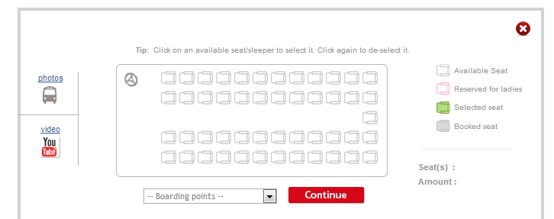
Figure 4: Travel Decision Helper to book tickets shows an empty bus which you can click your seats
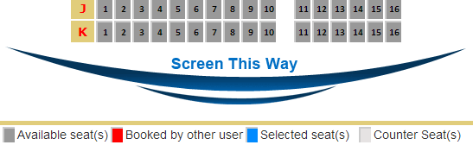
Figure 5: Cinema Decision Helper to book tickets shows theater seats which you can pick and positions with respect to screen.

By following the self service catalog which documents the patterns as above, an architect or designer would be aware of the issues in the self serve domains and the various ways to tackle them. Let us say that the architect wants to deploy a billing system. Multiple paths are possible through the patterns. For example to design a paperless billing system which provides e-bills, consider a pattern like Smart Pagination to display the bill, Remember me to show customers their frequently selected bill types, 360 degree view to store in the system the data that the customer has viewed the bill so that they can account for the same in case of any disputes.

Future Work

In the future we aim to evolve this to a pattern language, based on Figure 1. We also wish to extend this to mixed mode channels involving paper, interactive voice response systems and media consumption systems. We also want to pay more attention to customers who may have impairments of physical or cognitive variety.

We also aim to study how deeper engagement with customer can happen over online channels [12].Since service orientation is becoming a key architectural tenet we want to further integrate these patterns with service oriented architecture patterns as described in [8]. For example the Active Service Pattern which deals with service autonomy and temporal concerns can be envisioned as a service with a human participant that needs to be as autonomous as possible.

We also aim to study cloud provisioning and maintenance interfaces which have normal users and their effectiveness in making the right choices. Further this paper has treated B2B, B2C, C2C and B2B2C e-commerce models under the same umbrella so we wish to segregate this further with respect to the patterns and their primary context. Further the rise of Peer to Peer Platforms [11] also gives rise to self service patterns which can be studied.

acknowledgement

We wish to thank out our shepherd Dr Ernst Oberortner for his guidance.

REFERENCES
- Gamma E.,Helm R., Johnson R., Vlissides J.”Design Patterns. Elements of Reusable Object Oriented Software.”, Addison Wesley, 1995.
- N. L. Kerth and W. Cunningham. Using patterns to improve our architectural vision. IEEE Software, 14(1):53-59, Jan. 1997
- Xin Zhang; Zhongjie Li; Wei Sun; Zhongbo Jiang; Adams, J.; Verschueren, P.; , "Applying Pattern Approach for Solution Architecture Design: A Case Study in Retail Solution," e-Business Engineering, 2008. ICEBE '08. IEEE International Conference on , vol., no., pp.351-358, 22-24 Oct. 2008
- Rossi. “Patterns for Ecommerce Applications”. EuroPLOP 2000.
- Xiaohong Yuan1 and Eduardo B. Fernandez2, Patterns For Business-To-Consumer Ecommerce Applications, airccse.org/journal/IJSEA/current2011.html
- Rosenbaum, Stephanie; , "Creating usable self-service interactions," Professional Communication Conference (IPCC), 2010 IEEE International , vol., no., pp.344-349, 7-9 July 2010
- Neil Theresa. “Mobile Design Pattern Gallery”, O’Reilly, 2012
- Arnon Rotem Galoz, SOA Patterns, Manning, 2012
- Volter, Bettin, “Patterns for Model Driven Software Development”, EuroPLOP, 2004
- http://selfservicepatterns.blogspot.in/
- http://www.economist.com/news/leaders/21573104-internet-everything-hire-rise-sharing-economy
- Linda Rising, "Customer Interaction Patterns”, PLOP, 1999

